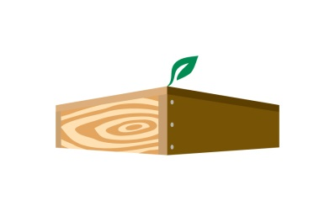
JFR/ /WSWP/ Bruce Jones Quarterly Newsletter

Our Vision: We use renewable resources to build the structures that house families and move products around the world.

Our Mission: We proudly use wood, a naturally renewable resource, to build value‐added, durable and cost‐effective products ensuring long‐term customer relationships for more than 160 years.

Core Value of the Quarter:
Be conscientious of social and environmental responsibilities:
- Be active in your community
- Recycle your waste
- Lead by example

Fun Fact:
The British royal family isn't allowed to play Monopoly.

Quotes:
“Failure is the condiment that gives success its flavor.”
― Truman Capote

“If you’re going through hell, keep going.”
― Winston Churchill

“I hated every minute of training, but I said, “Don’t quit. Suffer now and live the rest of your life as a champion.”
― Muhammed Ali

“Although the world is full of suffering, it is full also of the overcoming of it.”
― Helen Keller

“Always bear in mind that your own resolution to success is more important than any other one thing.”
― Abraham Lincoln

CEO Corner
A devastating fire isn’t something anyone ever wants to have occur. The good news is that no one, including the firefighters that responded, was hurt. The bad news is it will take time and effort to fully recover from the fire. Hats off to Tim Kiick and the management team for everything they’ve done to work towards becoming fully operational in less than two months. We don’t know what caused the fire, but going forward it’s critical that everyone performs the required housekeeping duties at the end of each shift, such as cleaning up debris and sawdust. Please report any machinery issues, particularly those that are electrical in nature. Finally, everyone should know where to go in the event of a fire during operating hours. If this had occurred during work, management would have needed to take a headcount to ensure everyone was accounted for. The drills we do may seem tedious, but if they can save a life, they’re certainly worth it!

Moving on, we have each business entity competing in a sandwich sale fundraiser in conjunction with the Berk’s County Alzheimer’s Walk on October 6th at the PSU Berks Campus. Please consider participating as it ties into the Core Value of the Quarter.

