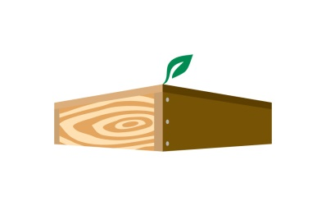
JFR/WSWP Quarterly Newsletter

Our Vision: We are a leader in our industry, we promote conservation and sustainable practices, and we are stewards of our community.

Our Mission: We proudly use wood, a naturally renewable resource, to build value‐added, durable and cost‐effective products ensuring long‐term customer relationships for more than 160 years.

Core Value of the Quarter:

We promote teamwork. Working together creates a more enriching work environment and generates better results. Don’t ever be afraid to ask for help.

Fun Fact: Tigers have striped skin as well as their fur.

Quotes:
“Remember upon the conduct of each depends the fate of all.”
― Alexander the Great
“Synergy — the bonus that is achieved when things work together harmoniously.”
― Mark Twain
“Ask not what your teammates can do for you. Ask what you can do for your teammates.”
― Magic Johnson
“I love to hear a choir. I love the humanity … to see the faces of real people devoting themselves to a piece of music. I like the teamwork. It makes me feel optimistic about the human race when I see them cooperating like that.”
― Paul McCartney

Effective September 1, we closed on the acquisition of a new company, Bruce L. Jones Contractor Co. This company manufactures wall panels at their Hanover location. They then truck the panels to the job site where their crews frame the building. They focus on multi-unit housing, mostly in the Baltimore area. We’re excited about the future and where this may take us as a company. The long-term plan is to consolidate the two businesses at one location in the Hanover area. The WSWP location will continue to operate independently in Auburn. It’s going to take a lot of collaboration and teamwork, between the management teams and all of the employees, to plan the future state of operations. If anyone has any questions, please feel free to ask Tim or me and we’d be glad to answer.
CEO Corner
