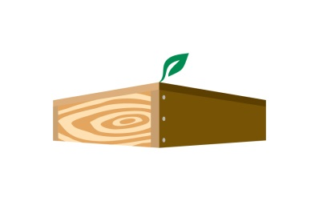
JFR/WSWP Quarterly Newsletter

Vision: We are a leader in our industry, promote conservation and sustainable practices, and are stewards of our community.

Mission: We proudly use wood, a naturally renewable resource, to build value‐added, durable and cost‐effective products insuring long‐term customer relationships for over 160 years.

Core Value of the Quarter:

Commitment – We honor our commitments. Our customers, our teammates and our vendors count on us to do what we say we’re going to do, when we say we’re going to do it. We follow through on our promises and we consistently ensure that everything is completed in accordance with expectations.

Commitment to the customer means giving 100% attention to their needs. The customer wants to believe they are the most important one to you, the supplier.

Successful teamwork is built on a foundation of trust. You must establish trust with your peers, cultivate it through actions and words, and most importantly, work tirelessly to maintain that trust.

Our vendors count on us to receive goods and follow business procedures that insure payment within the terms set within the buy/sell agreement. They are committed to providing what we need in the time frame required to produce products for our customers as promised.

Fun Fact:

“Applesauce was the first food eaten in space by an American astronaut.” – National Geographic
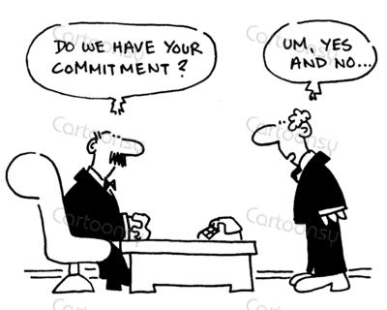
Commitment Quotes:
“There are only two options regarding commitment. You’re either in or out. There is no such thing as life in-between.” – Pat Riley, Hall of Fame Basketball Coach
“A winner makes commitment. A loser makes promises.” - Anonymous
“It’s not whether you get knocked down, it’s whether you get up.” – Vince Lombardi
“Commitment is an act, not a word.” – Sartre
CEO Corner
Your commitment to do something is worthless unless you're willing to apply 100% of your effort to follow through on your promise 100% of the time.

