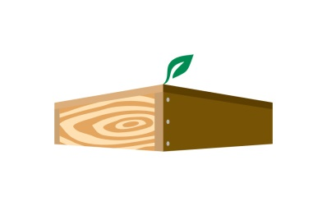
JFR/WSWP Quarterly Newsletter

Our Vision: We are a leader in our industry, we promote conservation and sustainable practices, and we are stewards of our community.

Our Mission: We proudly use wood, a naturally renewable resource, to build value‐added, durable and cost‐effective products ensuring long‐term customer relationships for more than 160 years.

Core Value of the Quarter:

Quality – We’re performance-driven and quality conscious. We operate with a sense of urgency to get things done. We promote continuous improvement in everything we do. We take the extra time to do things right the first time. We don’t take shortcuts just to get the job done. We respond to issues, questions and concerns quickly.

A Definition of Wood Quality
Many attempts have been made to define wood quality (Keith 1985), but the definition proposed by Mitchell (1961)¹ appears to be the most widely cited: "Wood quality is the resultant of physical and chemical characteristics possessed by a tree or a part of a tree that enable it to meet the property requirements for different end products". Almost everybody agrees that wood quality must consider specific end uses, and this definition duly “emphasizes their significance, but it fails to consider other aspects that are of importance to manufacturers, foresters or customers. It cannot, therefore, be applied to the forest management/manufacturing/customer chain.
As wood properties affect various aspects of the manufacturing process, wood quality must be defined in terms of the value recovery chain. In addition, the definition needs to include serviceability, and cover attributes of interest to end-users, which may or may not have a direct impact on manufacturing, but will continue to matter long after the product has been sold and installed. This paper accordingly defines wood quality as "all wood characteristics that affect the value recovery chain and the serviceability of end products."
¹Mitchell, H.L. 1961: A concept of intrinsic wood quality and nondestructive methods for determining quality in standing timber. Report No. 2233, Forest Products Laboratory, Madison, Wisconsin.
Fun Fact: “Paraskavedekatriaphobia is the fear of Friday the 13th.”

Quality Quotes:
“Quality means doing it right when no one is looking.”
― Henry Ford
“Quality is not an act, it is a habit.”
― Aristotle
“The quality I most admire in a man is steadfastness.”
― David Mamet
CEO Corner
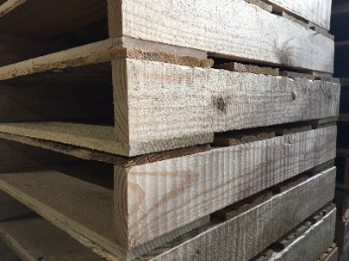
Our company goal for 2016 was less than 2% rejection rate on delivered goods. We achieved a rate of .11%. That means we built over 1 million units and had only 1,100 delivered goods returned. Great job! Our goal for 2017 is <1%, but I’d like us to drop that return rate by 50%! Can we do it?

